“My Account” tab
Use this tab to update your email address or password, or girl information.


While logged into Digital Cookie, click on the “My Account” at the top of the page



You can either change your email or password OR click on the “Girl Account” to change her name or email address (if she is 13 or over)

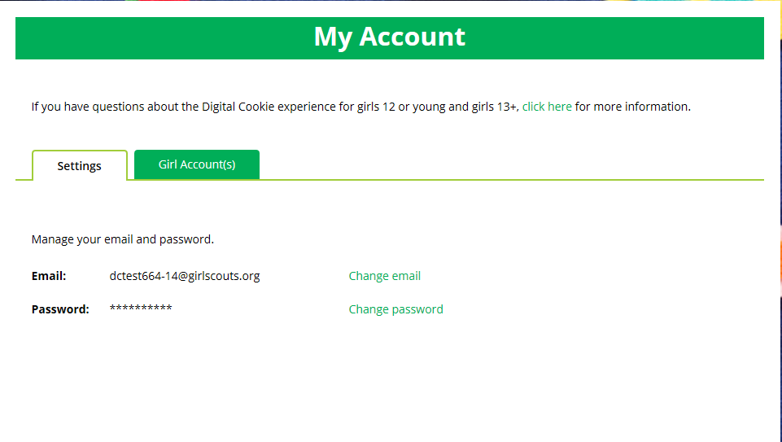


Clicking on the “Change Email” will give you a screen to update your email address to a new one.
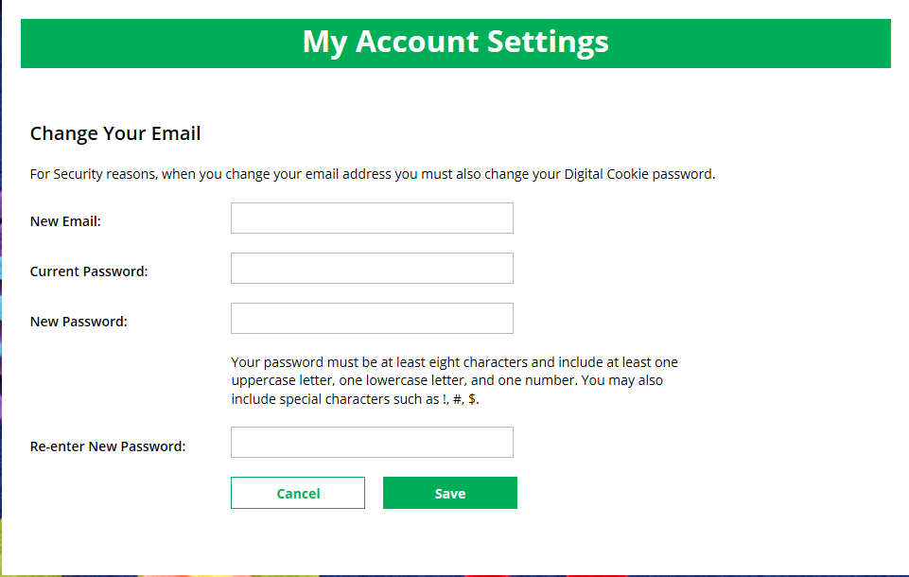



If you are also a Troop or Service Unit Volunteer, you will be unable to change your email address here. You will need to update your email address in eBudde instead.

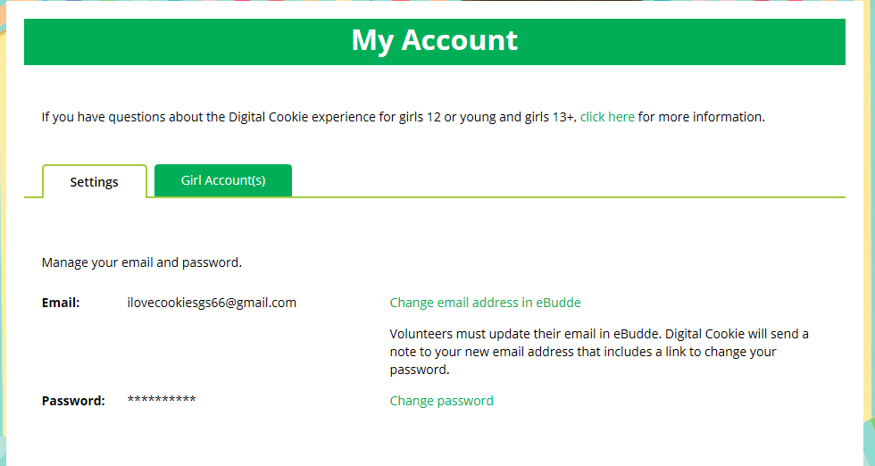


Clicking on the “Change Password” will give you the opportunity to update your password

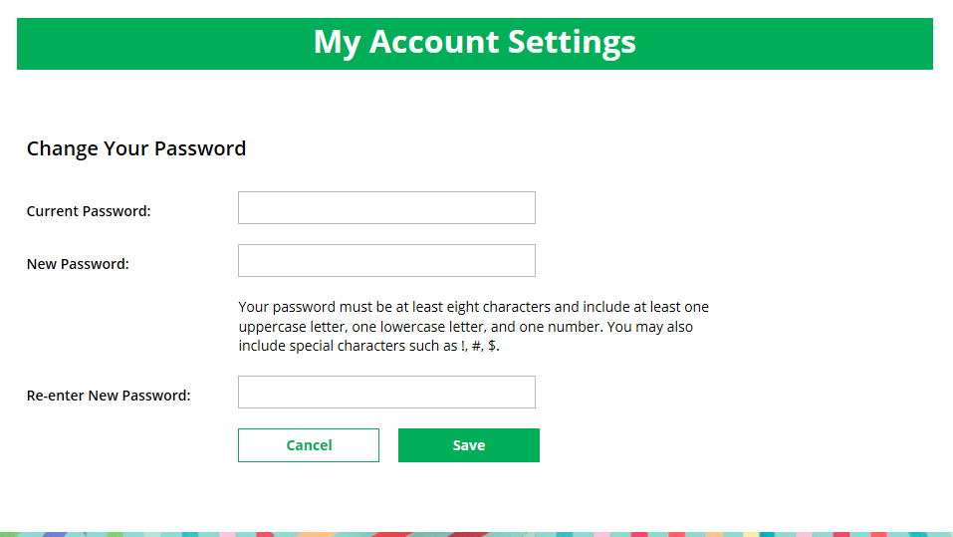


Clicking on the “Girl Account” tab will allow you to update the girl preferred first name and girl email address if she is 13 or over.

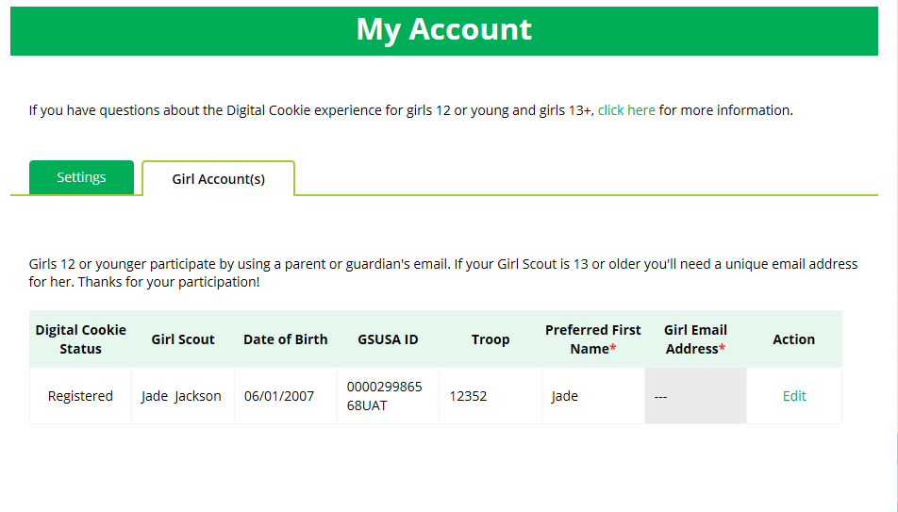

NOTE: Updating your email in Digital Cookie does not mean it will be updated in your council membership system. Please login to MyGS to update your email there as well.

